Fostering Creativity Through Collaborative
Legacy Murals

Lara Fahnlander
April, 2015
Master of Arts
University of Florida

Overview
This paper will look at research that investigates how to cultivate creative thinking through art in student learning environments. The artwork for this final project reflects the concepts of creativity and collaborative spirit. I will explain the process I experience as I create Legacy Murals with fifth graders and demonstrate how our process ties in with ideas that promote creativity among student populations.
Discussion, Individual Brainstorming, Spatial Relations and Creativity
Upon meeting the students, I explain my purpose is to create a Legacy Mural with them that will be their transmission to future students at Holualoa Elementary. I give them six key words that will be important to remember through the process ahead: flow, listen, give, support, change and unity. We go outside and form a circle. I tell them of a local reforesting project at nearby Mauna Kea to restore the depleted Koa tree population and leave a legacy of 1.2 million new trees for the future people of Hawaii (legacytrees.org). I then ask them to take a few quiet minutes to think of what is special for them in this place and what they would like to pass down to future students at their school. “Art educators may inspire for a plethora of creative solutions by presenting a problem open for interpretation and students benefit by having an opportunity to share their own lived experiences” (Bryant, 2010, p. 45). Each child puts their hand into the circle when they have an idea, and then are welcome to share any thoughts as we go around the circle.
Afterward, back inside, I demonstrate using the Elements of Shape to replicate an object in the room. I ask them to fold back part of their paper and write their name on it. As they practice using the Elements of Shape (Brooks, M., 1996) to draw an item using spatial relations, I practice memorizing their names and begin to know them as individuals. Participants also choose a letter of the English alphabet and make it in four ways using: straight lines, curve lines, like something in nature, and their in own style. This is an opportunity to learn new drawing vocabulary and experience it in action, using simple guidelines, then manipulating elements into complex and creative designs as they depict nature and their own style.
Aesthetic Inquiry
The next session begins with a survey of fifteen murals from around the world. Students are encouraged to comment on what they see, what they like, emotional reactions, personal perspective and insights. The murals are primarily realistic and the concepts of: shading, scale, overlapping, background, middle ground, foreground, surrealism, and trompe l’oeil are discussed. As Pavlou (2013) describes:
… a discussion with the children about an artwork took place following the aesthetic enquiry mode, which involved the active engagement of the children. The empirical data demonstrated that within this framework viewing artworks enabled children to embrace and practice the capacities of noticing deeply, embodying, questioning, creating meaning and taking action. In particular, the children were able to describe in detail what the artwork contained, to make connections and to wonder. (p. 84)
It is so fun to hear them “ou” and “aww” over various works and find words that describe thoughts of each piece. I enjoy listening to their ideas and wonders about how pieces are created and why. Pavlou explains why it is important to encourage aesthetic enquiry before asking students to delve into their own creation process:
Aspects of the pedagogical framework include the belief that art can be interpreted on direct, personal connections which set the preconditions for encouraging a particular kind of enquiry, an aesthetic mode of enquiry, which consequently encourages the development of possibility thinking. When talking about art is combined with creating art then possibility thinking is given a visual form; children are enabled to transform their ideas into an art form. (p. 86)
So after much preparation, the students renew brainstorming, but this time with peer groups.
Peer: Conversation, Brainstorming, Reflection, and Collaboration
Students are asked to form their own teams of three to four students. “Passing control to children is essential in actively engaging the children in their learning” (Pavlou, p. 86). Each group designates members to fill the role of: Writer, Speaker, Flow, and Support. They work as a team to generate ideas for themes and concepts of importance to them. “Perception is the stage in the cycle of visual inquiry where creative thinking skills fluency and flexibility are used” (Heid, 2008, p. 44). Perception is often the first of four stages of visual inquiry: perception, conception, expression and reflection, and is closely paired with conception phase that moves a student from questions and investigation felt, into forming abstract ideas (Heid, 2008). Each team then funnels their list down to one top idea to share with the class. Pupils in Speaker role present their group’s idea and through anonymous voting, the theme with the most votes is elected. When voting is close, I do a second voting between popular ideas, or merge ideas based on student desire and input. Once themes are chosen, students do individual thumbnail sketches of images depicting the theme. Often the third of the four stages of visual inquiry, “The expression phase suggests a final form or composition that the ideas take, but this is far from absolute” (Heid, 2008, p. 45). After looking at the sketches, ideas begin to emerge. Students then do a second, more focused round of four more individual thumbnail sketches. From all sketches I draw a preliminary mural design on their themes “Let Your Imagination Fly” and “Protect Nature and One Another” and Miho Morinoue designs “Love Hawaii, Our Culture and School”, incorporating an idea from each participant.
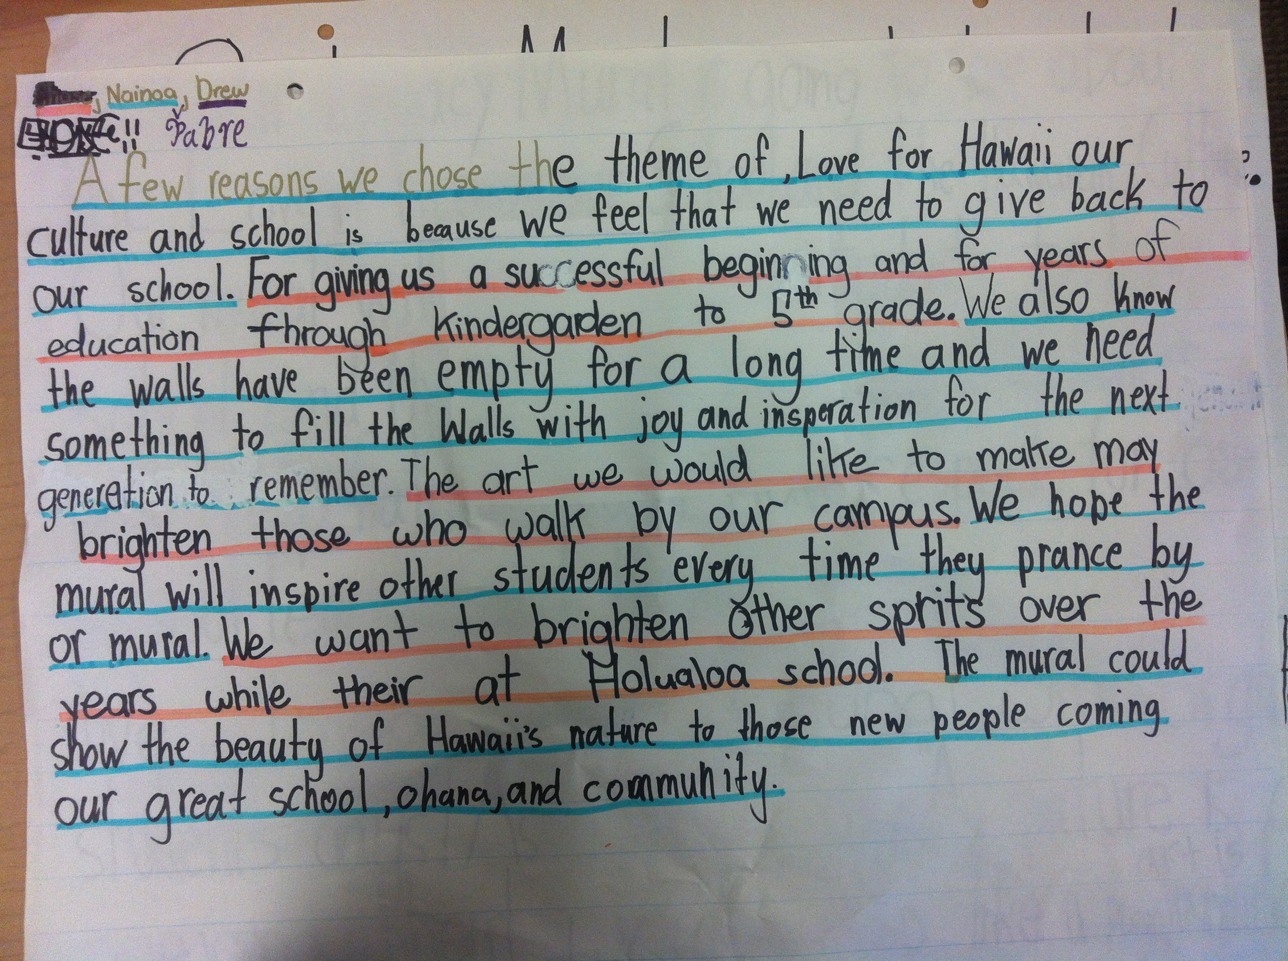
Figure 1. Student Proposal for Mural Approval

Interdisciplinary Study
With classroom teachers, students outline and write a proposal to the administration seeking support and approval for their mural to be executed. Some classes write letters (see Figure 1), while others prepare oral presentations to explain the reasoning behind their theme and why their chosen idea is a worthwhile cause, deserving of support. Writing and presenting objectives and rationale, connecting to the wider community and gaining approval for this real life problem help students understand more aspects of the social practice process (Guyotte, Sochacka, Constantino, Walther & Kellam, 2015).
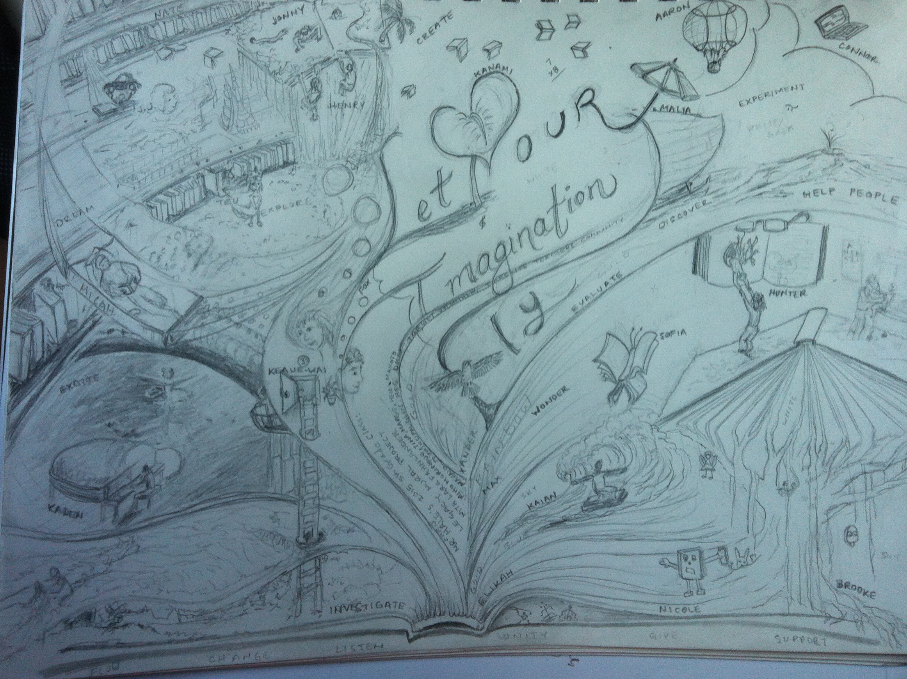
Figure 2. Let Your Imagination Fly

Critique, Editing and Constructing
When I present the sketch to the children I show the correlating drawing incorporated from each student’s sketches. Their name is placed in the mural next to the idea they contribute. After sharing the design (see Figure 2), I address areas that are unfinished and seek more input from the class to complete. “Feedback that focuses on more than one aspect of learning- the product, process, and progress- yields maximum benefits to students” (Low, 2015, p. 44). I also discuss ideas of my own that I added, so students have the opportunity to approve or decline the additions. I ask for any additional suggestions and overall approval before finishing the preliminary design. The fourth stage of visual inquiry, “Reflection suggestions careful thought. It is the process of taking into consideration previous actions, decisions, and ideas” (Heid, 2008, p.45). I find this a good way to introduce students to the idea of critique. When I am first in the position of being critiqued, students can experience the critique from a non-threatening perspective of commentator rather than receiver. I can also model good listening to suggestions from others and how to have an open mind to change in one’s artwork. Gude (2010) explains there are many factors in stimulating creativity in the art making process:
Conditions of psychological safety and freedom that make creativity possible are produced, not merely by the teacher’s wishes, but rather by how his or her attitude manifests itself in the range of choices that affect course content, work styles, class discussions, peer interactions, opportunities for playful engagement with materials, ideas, assessment or the lack thereof. (p. 34)
After students gain administrative support and I gain student approval for the design, I paint rough lines to separate areas of the mural wall so students can work in teams to block in color. When blocking is complete, artists will come in and help fill in background details. The following painting sessions students can devote to working on their own contributed portions and decide what details they will add. “During this phase, the artwork may undergo considerable change as the artist comes to terms with its physical parameters, yet the creation of the work is not limited to this phase alone” (Mace & Ward, 2002).
Conclusion
In order to design this piece I could not disappear inside a box and make something. The nature of the artwork itself required me to be creative while collaborating, so I constantly stay open to new ideas of others and how their ideas positively affect the artwork as a whole. Through discussion, brainstorming, sketching and critique, student form ideas, thus transforming a vague concept like a Legacy Mural into a meaningful, personal construction for students to experience in concrete action. My thanks to the Donkey Mill Art Center, Holualoa Elementary and the Target grant program for making this creative learning possibility a reality and to the University of Florida, Masters in Art Education program for encouraging me to reflect on my growth and learning from the experience.

References
Brooks, M. (1996). Drawing with Children: A creative method for adult beginners too. New York, NY: Putnam.
Bryant, C. (2010). A 21st-century art room: The remix of creativity and technology. Art Education 63(2), 43-48.
Gude, O. (2010). Playing, creativity, possibility. Art Education 63(2), 31-37.
Guyotte, K. W., Sochacka, N. W., Constantino, T. E., Walther, J., & Kellam, N. N. (2014). STEAM as social practice: Cultivating creativity in transdisciplinary spaces. Art Education 67(6), 12-19.
Heid, K. (2008). Creativity and imagination: Tools for teaching artistic inquiry. Art Education 61(4), 40-46.
Low, S. (2015). “Is this okay?” Art Education 68(1), 43-49.
Mace, M. & Ward, T. (2002). Modeling the creative process: A grounded theory analysis of creativity in the domain of artmaking. Creativity Research Journal, 14(2), 179-92.
Pavlou, V. (2013). Investigating interrelations in visual education: Aesthetic enquiry, possibility thinking and creativity. International Journal of Education through Art 9(1). 71-88.

