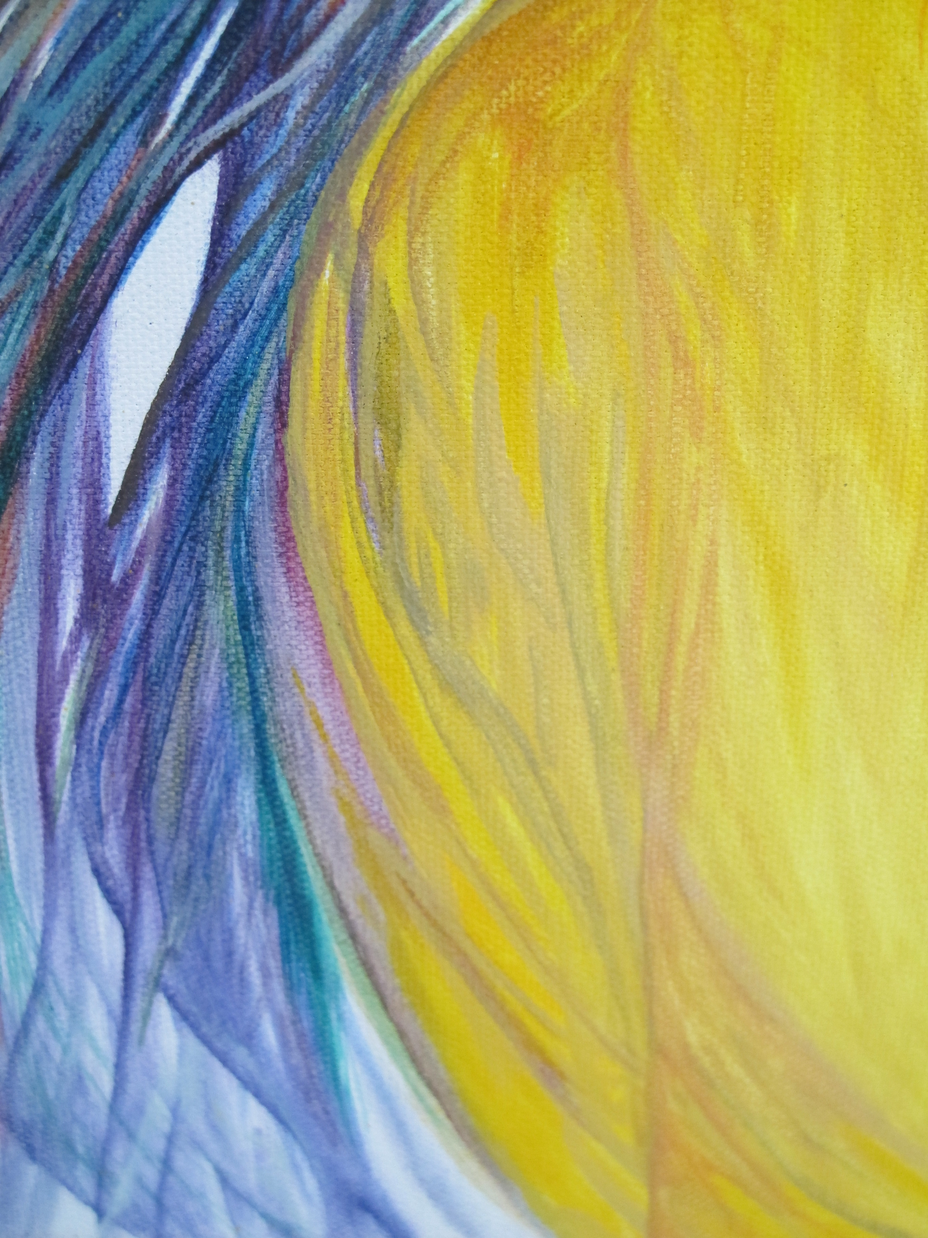
Teaching Artist since 1997
Lara Fahnlander
arteducationnation@gmail.com, larafahnlander.weebly.com

Education and Arts Training

2017: Master of Arts in Art Education from University of Florida (UFL)- Gainesville
Capstone Project- Developing Creatively: Focus on Personal Practice
Committee: Dr. Jodi Kushins, and Dr. Craig Roland (G.P.A. 3.97)
2008: Alaska Pacific University- Alaska Alive, Culturally Responsive Schools (GPA 4.0)
2007: Nationally Highly Qualified in Art Education- Praxis
2007: Nationally Highly Qualified in Elementary Education- Praxis
2004: Bachelor of Science- University of Wisconsin-Superior (G.P.A. 3.86)
Elementary Education (Summa Cum Laude) Minors: Art, Early Childhood
2004: Student teaching in Nelson, New Zealand (Grades 4-5) Nelson Central School
2003: Student teaching in Proctor, Minnesota (Grade: K) Bay View Elementary
1997: Selected to attend Perpich Center for the Arts: Visual Art Department

Most Recent Arts Training

2016: Digital Video Studio Course with J.J. Higgins, UFL
2016: Monoprintmaking Studio Course with Patrick Grigsby, UFL
2016: Design Thinking Studio Course with Brian Slawson, UFL
2015: Notan Printmaking Studio Course with Lindsay Landers, Holualoa, Hawaii
2015: Contemporary Issues in Art Education with Dr. Linda Fischer, UFL
2014: Art in Alternative Settings with Dr. Jodi Kushins, UFL
2014: History of Art Education with Dr. Elizabeth Delacruz, UFL
2013: Digital Image Studio Course with Alan Calpe, UFL
2012: Curriculum Design in Teaching Art with Dr. Craig Roland, UFL
2011: On site: Egypt, Israel, Palestine, Jordan and Greece- studying local arts
2010: On site: Bali, Sing., Malaysia, Thailand, Camb., Laos, & Nepal- studying local arts
2008: Scholarship winner to Alaska ICE training- Anchorage, Alaska

Professional History

Grants
2015: Target Grant: Donkey Mill Art Center, Holualoa, Hawaii- Legacy Murals Project
2008: Association of AK School Boards: Alaska Initiative for Community Engagement
$2000 for Community grant program: Delta Junction AK, “Fiber Friends”

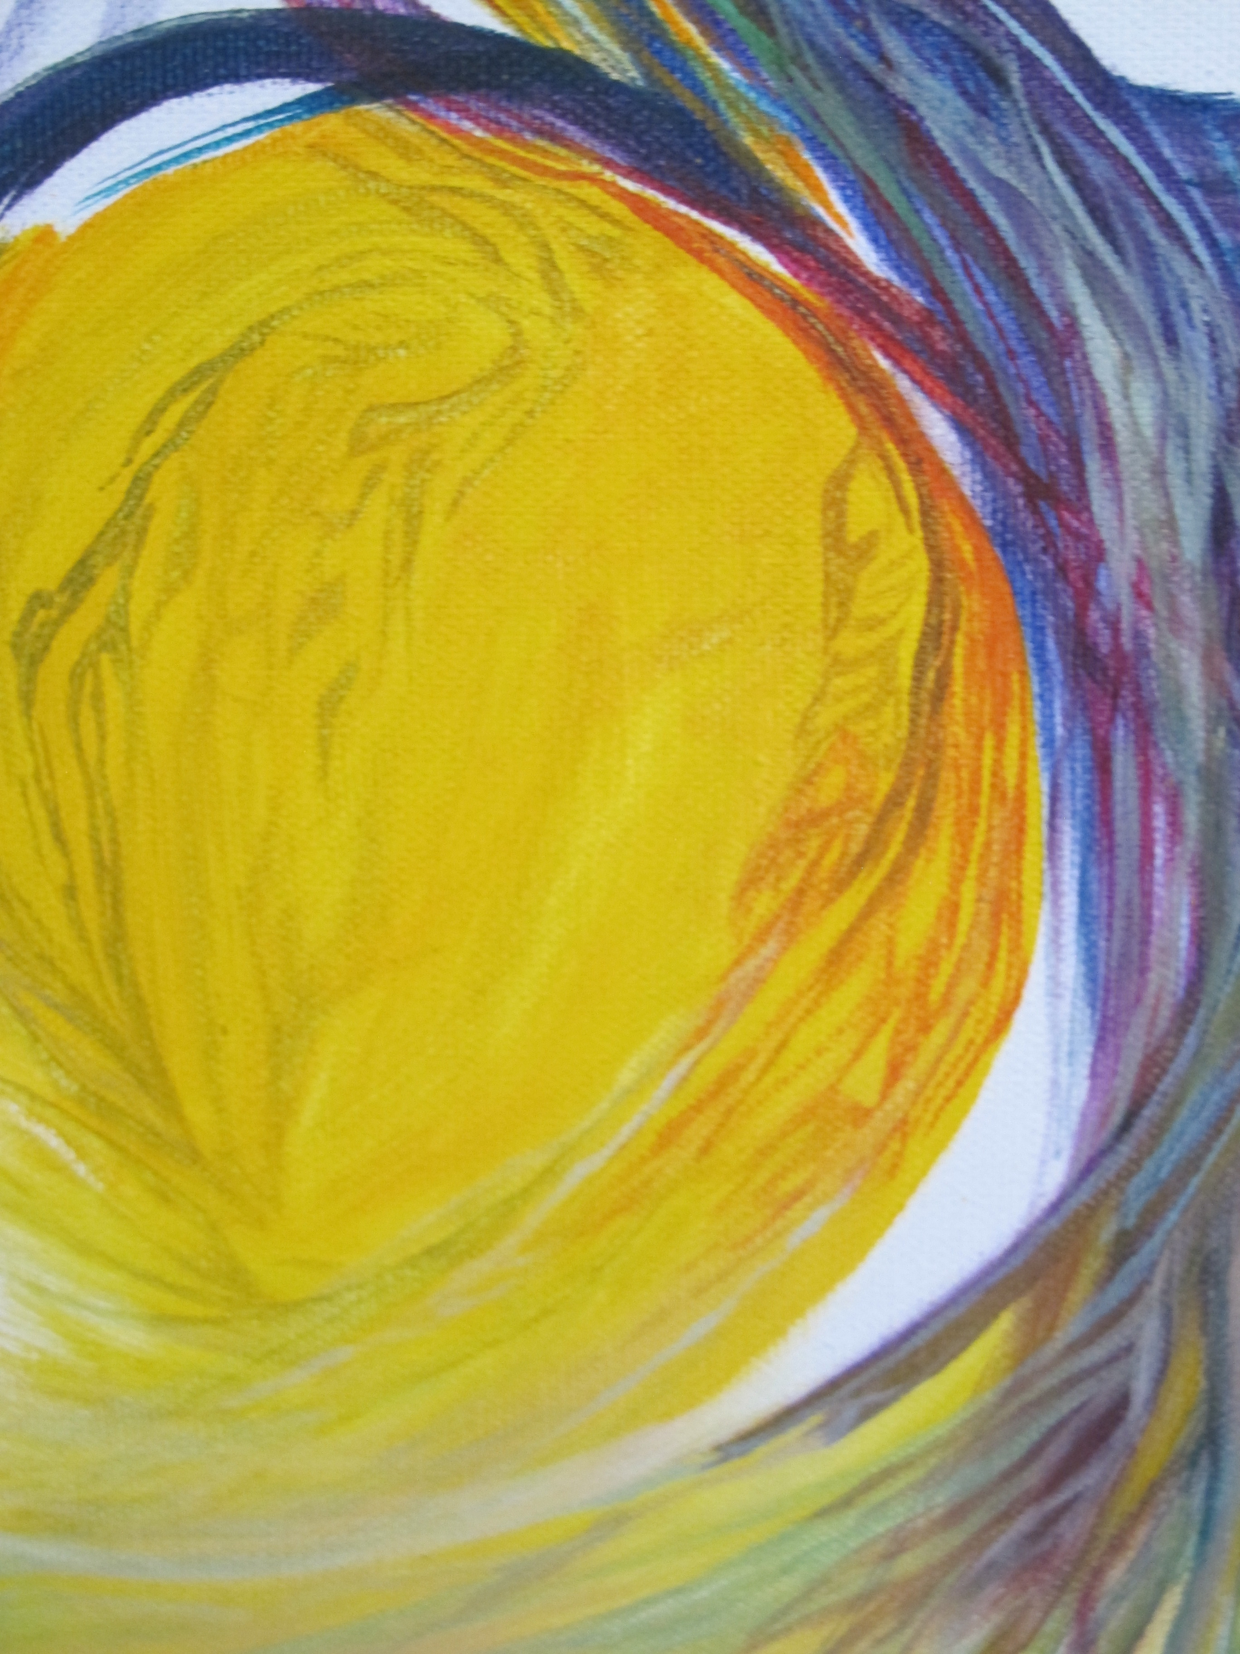
Awards
2009-2008: Artsonia Leadership Award: Family and Community Involvement in Education; Artsonia Leadership Award: Technology Integration in the Arts
2005: ETS Recognition of Excellence on Praxis Score
Elementary Education: Content Knowledge

Publication
2009 Student work chosen to represent AK, Published in: Create Your State
2003 Image: Fluid Vertices the Eye Spies Published in: Pharmako Gnosis

Commissions
Over 30 Public and Private Murals …here are a few
2004-2017: Commission murals in Minnesota, Alaska, Hawaii, California & Kansas
2015: Legacy Murals Project; Holualoa Elementary, Hawaii
2013: World Globe Mural; Delta Elementary, Alaska
2008: Couchsurfing.com, Event backdrop; Homer, Alaska to San Francisco, California
2006: Wadena Alley Arts Project; Wadena, Minnesota

Exhibitions
2015: “Technonatura” Donkey Mill Art Center, Holualoa, Hawaii
2013: “Aurasma Student Showcase” ASTE Conference, Anchorage, Alaska
2010-2008: “Art in the Capital” Juneau, AK; Student work by Delta Elementary
2010: “All Kids Can Create” CVS, international traveling show, Student artwork chosen- won flight and accommodation for two to Washington D.C. for opening.
2007: "Deltana Fair” Delta Junction, Alaska

Teaching Art (other teaching Experience excluded)
2017:“Create in Clay”, The Folk School of Fairbanks, AK (Ages 8-16)
2015: Art Specialist; Gallup, NM (PreK-5th)
2015: “Drawing Cartoons and Animals” Creative Heart Arts; Delta Jct, AK (Ages 6-13)
2015:“Legacy Murals Project”, “Self-Portraits” Holualoa Elementary, HI (4th-5th)
2015:“Get Art, Get Nature, Get Real” Donkey Mill Art Center, Holualoa, HI (Ages 6-14)
2013-2012: Art Specialist; Delta Elem, and Delta HS; Delta Jct, AK (K-3rd), (9th-12th)
2010-2007: Art Specialist; Delta Elementary; Delta Junction AK (K-5th)
2006-1997: Art Specialist: Minneapolis Summer Schools, MN (Ages 5-12)
2003-2001: “Art of Goo” Duluth Art Institute Instructor, Duluth, MN (Ages 6-12)
2002-2001: “Painting for Kids” Waterfront Artworks; Duluth, MN (Ages 7-12)

